**PIPELINE IMPLEMENTATION OF A PROCESSOR**

**RISC** **Processor (MPIS 32)**

* 32-bit General Purpose Registers (GPRs), **R0** to **R31**
  + **R0** is constant; cannot be written.
* Special Purpose 32-bit register, **Program Counter (PC)**
* Memory Word size is 32-bits

**Instruction Sets:**

1. **Load and Store**

LW R2, 124(R8) //R2 = Mem[R8+124]

SW R5, -10(R25) //Mem [R25 – 10] = R5

1. **Arithmetic and Logic Instructions** (Only Register Operands)

ADD R1, R2, R3 //R1 = R2 + R3

ADD R1, R2, R0 //R1 = R2 + 0 (Moving)

SUB, AND, OR, MUL, SLT (Set Less Than)

SLT R5, R11, R12 //IF R11 < R12, R5 = 1; else R5 = 0

1. **Arithmetic and Logic Instructions** (Immediate Operand)

ADDI R1, R2, 25 //R1 = R2 + 25

SUBI, SLTI

|  |  |
| --- | --- |
| **Instructions** | **Op-Code** |
| ADD | 000000 |
| SUB | 000001 |
| AND | 000010 |
| OR | 000011 |
| SLT | 000100 |
| MUL | 000101 |
| HLT | 111111 |

1. **Branch Instructions**

BEQZ R1, Loop //Branch to loop if R1 = 0

BNEQZ R1, Label //Branch to label if R5! = 0

1. **JUMP Instruction**

J Loop //Branch to Loop unconditionally

1. **Miscellaneous Instructions**

HLT //Halt execution

**R-Type Instruction Encoding**

**31 26 25 21 20 16 15 11 10 6 5 0**

|  |  |  |  |  |  |
| --- | --- | --- | --- | --- | --- |
| **opcode** | **rs** | **rt** | **rd** | **0** | **0** |

**Example**

|  |  |  |  |  |
| --- | --- | --- | --- | --- |
| **SUB** | **R5, R12, R25** | | | |
| 000001 | 01100 | 11001 | 00101 | 00000 000000 |
| SUB | R12 | R25 | R5 | Unused |
| = 05992800 (in HEX) | | | | |

**I-Type Instruction Encoding**

**31 26 25 21 20 16 15 0**

|  |  |  |  |
| --- | --- | --- | --- |
| **opcode** | **rs** | **rt** | **Immediate Data** |

|  |  |
| --- | --- |
| **Instructions** | **Op-Code** |
| LW | 001000 |
| SW | 001001 |
| ADDI | 001010 |
| SUBI | 001011 |
| SLTI | 001100 |
| BNEQZ | 001101 |
| BEQZ | 001110 |

**Examples**

|  |  |  |  |
| --- | --- | --- | --- |
| **LW** | **R20, 84(R9)** | | |
| 001000 | 01001 | 10100 | 0000000001010100 |
| LW | R9 | R20 | Offset |
| = 21340054 (in HEX) | | | |

|  |  |  |  |
| --- | --- | --- | --- |
| **BEQZ** | **R25, Label** | | |
| 001110 | 11001 | 00000 | yyyyyyyyyyyyyyyy |
| LW | R25 | unused | Offset |
| = 3b20YYYY (in HEX) | | | |

**J-Type Instruction Encoding**

**31 26 25 0**

|  |  |
| --- | --- |
| **opcode** | **Immediate Data** |

|  |  |
| --- | --- |
| **Instruction** | **Op-Code** |
| J | 010000 |

**//J-type Instructions are not Implemented Here**

**MPIS 32 Instruction Cycle**

1. IF : Instruction Fetch
2. ID : Instruction Decode / Resistor Fetch
3. EX : Execution/Effective Address Calculation
4. MEM : Memory Access/Branch Completion
5. WB : Register Write-back

**ADD R2, R5, R10 ADDI R2, R5, 110**

|  |  |  |
| --- | --- | --- |
| **IF** | IR | 🡨 Mem [PC] ; |
| NPC | 🡨 PC + 1 ; |
| **ID** | A | 🡨 Reg[rs] ; |
| B | 🡨 Reg[rt] ; |
| **EX** | ALUOut | 🡨 A + B ; |
| **MEM** | PC | 🡨 NPC ; |
| **WB** | Reg[rd] | 🡨 ALUOut ; |

|  |  |  |
| --- | --- | --- |
| **IF** | IR | 🡨 Mem [PC] ; |
| NPC | 🡨 PC + 1 ; |
| **ID** | A | 🡨 Reg[rs] ; |
| Imm | 🡨 (IR15)16 ## IR15..0 |
| **EX** | ALUOut | 🡨 A + Imm ; |
| **MEM** | PC | 🡨 NPC ; |
| **WB** | Reg[rt] | 🡨 ALUOut ; |

**LW R2, 200(R6) SW R2, R5, 110**

|  |  |  |
| --- | --- | --- |
| **IF** | IR | 🡨 Mem [PC] ; |
| NPC | 🡨 PC + 1 ; |
| **ID** | A | 🡨 Reg[rs] ; |
| Imm | 🡨 (IR15)16 ## IR15..0 |
| **EX** | ALUOut | 🡨 A + Imm; |
| **MEM** | PC | 🡨 NPC ; |
| LMD | 🡨 Mem[ALUOut] ; |
| **WB** | Reg[rt] | 🡨 LMD ; |

|  |  |  |
| --- | --- | --- |
| **IF** | IR | 🡨 Mem [PC] ; |
| NPC | 🡨 PC + 1 ; |
| **ID** | A | 🡨 Reg[rs] ; |
| B | 🡨 Reg[rt] ; |
| Imm | 🡨 (IR15)16 ## IR15..0 |
| **EX** | ALUOut | 🡨 A + Imm ; |
| **MEM** | PC | 🡨 NPC ; |
| Mem[ALUOut] | 🡨 B ; |
| **WB** |  | ------ |

**BEQZ R3, Label**

|  |  |  |
| --- | --- | --- |
| **IF** | IR | 🡨 Mem [PC] ; |
| NPC | 🡨 PC + 1 ; |
| **ID** | A | 🡨 Reg[rs] ; |
| Imm | 🡨 (IR15)16 ## IR15..0 |
| **EX** | ALUOut | 🡨 NPC + Imm; |
|  | cond | 🡨 (A = = 0) ; |
| **MEM** | PC | 🡨 NPC ; |
| If(cond) PC | 🡨 ALUOut ; |
| **WB** |  | ------ |

**Data Path (MIPS32 Non-Pipelined Design)**

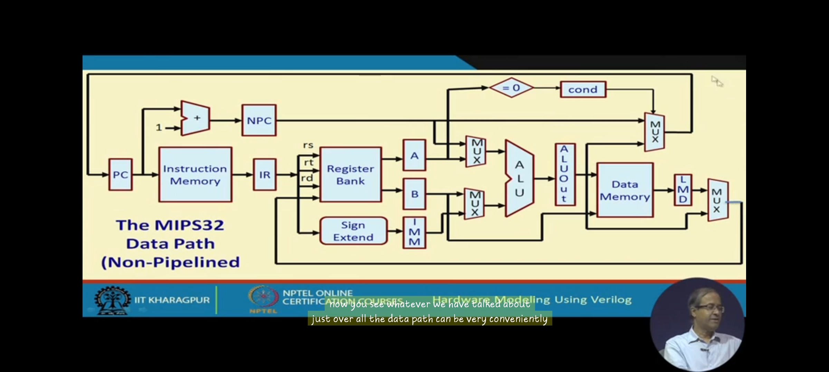

**Data Path (MIPS32 Pipelined Design)**

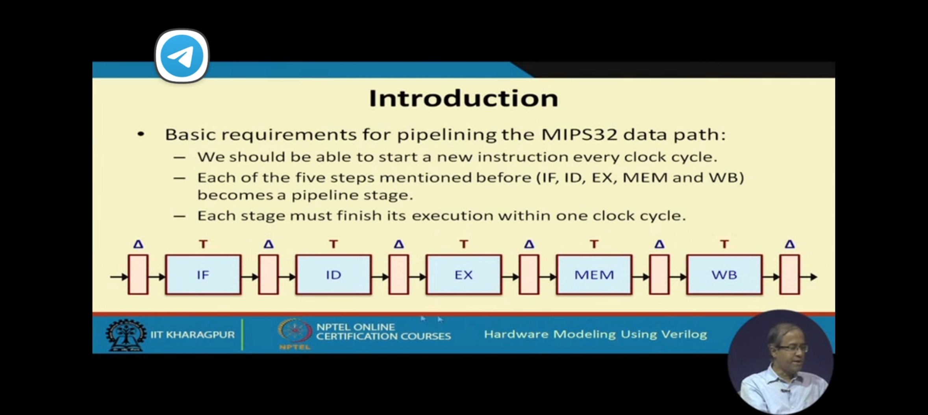

|  |  |  |  |
| --- | --- | --- | --- |
| **IF_ID** | **ID_EX** | **EX_MEM** | **MEM_WB** |

**IF Stage**

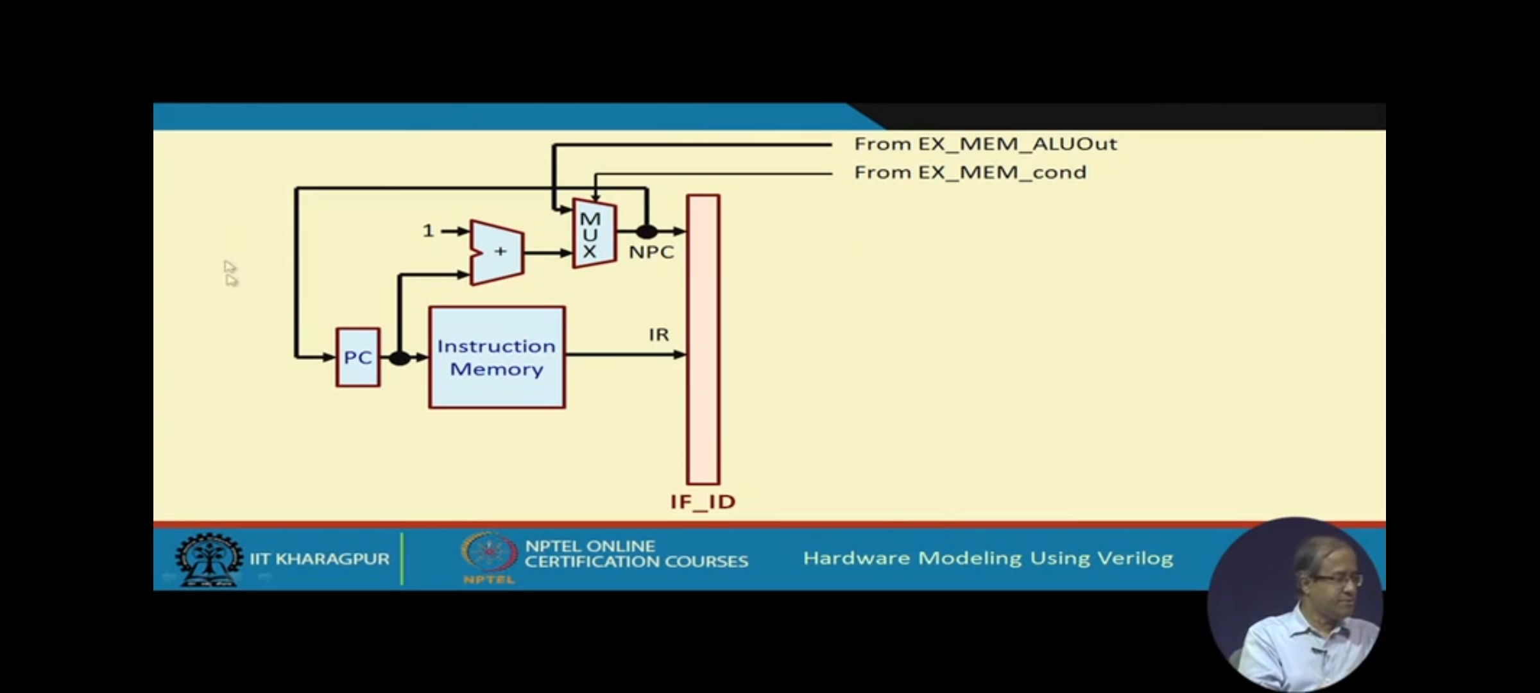

**ID Stage**

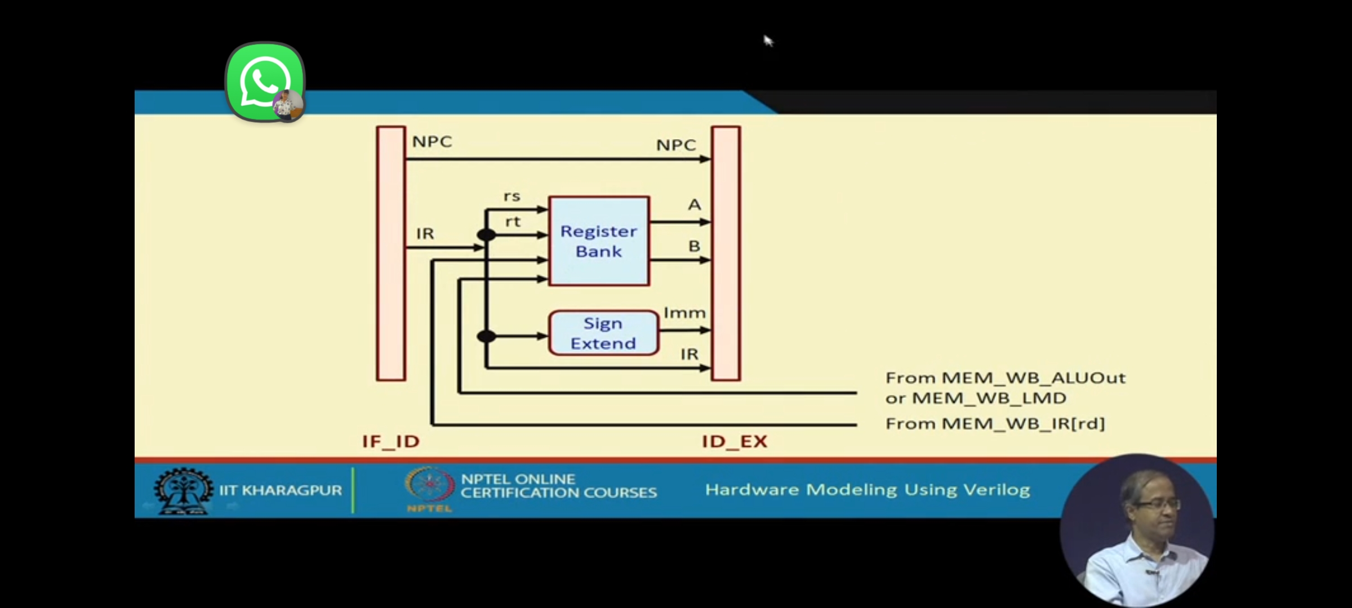

**EX Stage**

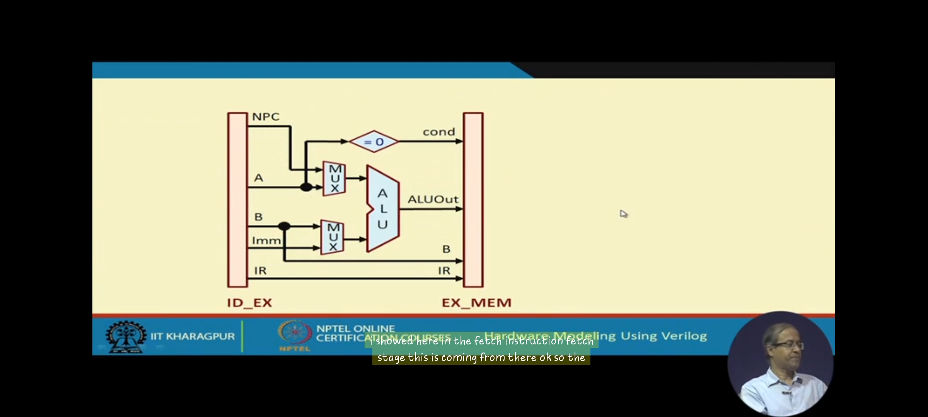

**MEM Stage**

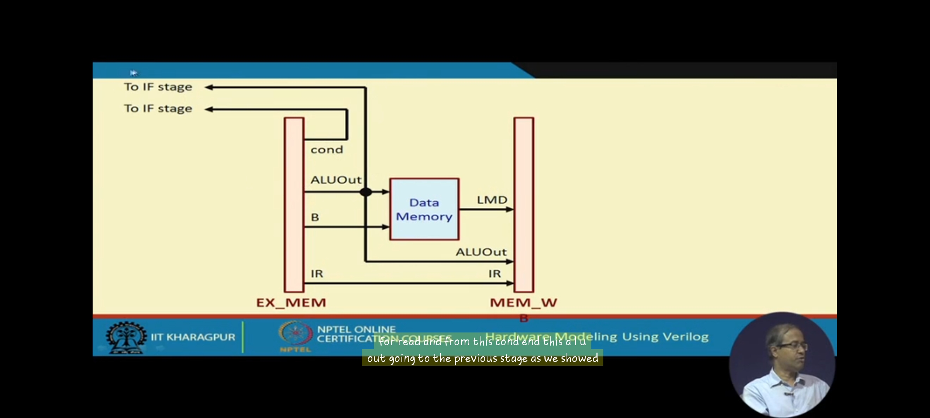

**WB Stage**

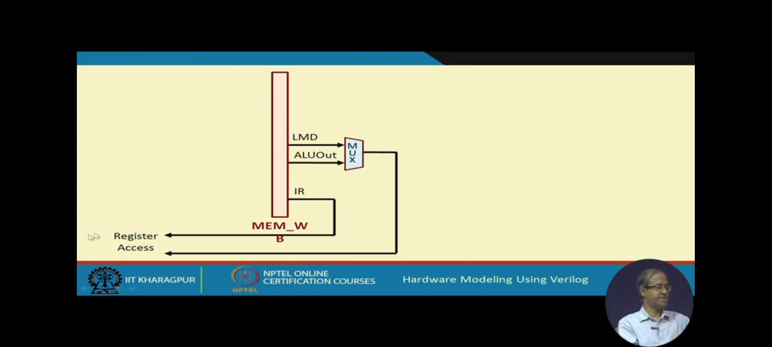

**Data Path (MIPS32 Pipelined Design)**

